Automation Anywhere®
TPAM Components
User Manual

DOCUMENT PURPOSE
The Process Document has been designed for use on process documentation efforts. Approvals must be obtained prior to implementation of a new process or updates to this document.

Automation Anywhere Client Setup
Template Released [Date]
Copyright © 2016 - Citi
All rights reserved. Information contained herein is for internal use and may only be used for business purposes authorized by Citi.
2/7

Document Control

- Document History

Version | Date | Status:  <Draft/ Final> | Author | Comment / Changes from Prior Version
1.0 | June 21, 2016 | First version | Denis Borozan | First version

- Document Reviewers/Approvers

Name | Position (e.g. Client Manager, Project Manager etc.) | Reviewer (only) | Reviewer and Approver
Gennadiy Makovoz | Application Owner
Michael Liberov | Technology Manager

Table of Contents
1. Introduction 4
2. Topology Diagram 5
3. Logical Diagram 6
4. TPAM MetaBot Component 7
4.1 TPAMClient.dll 8
4.2 TPAM MetaBot Logic 10
5. TPAM Task Bot Component 11
5.1 Setup TPAM MetaBot 11
5.2 Configuration file 12
5.3 Retry logic 13
5.4 Logging 13
6. TPAM Component Installation steps 14

Introduction
The purpose of this document is to explain how to leverage ISG designed solution for integration of AutomationAnywhere robotics processes with TPAM compliance certified password management solution.
ISG solution utilizes TPAM App2App web service infrastructure which must be available for this component to work.

Topology Diagram
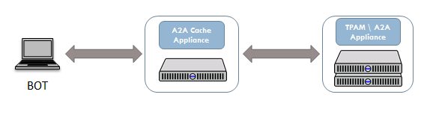
- The AA BOT initiates a Web Service request to the App2App infrastructure which is initially served by the App2App Cache appliance.
- The Cache appliance performs the authentication and releases the requested account password.
- Accounts and permissions are synchronized with the TPAM / App2App Appliance.

Logical Diagram
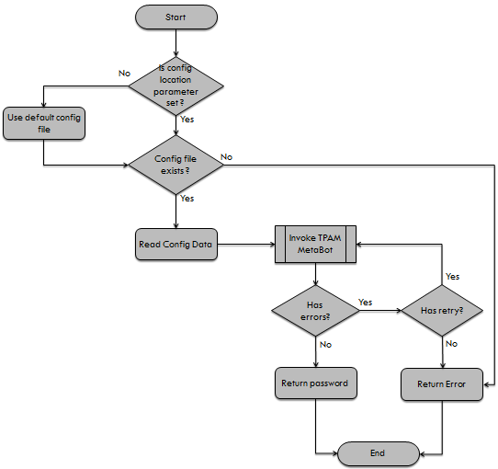
- Verifies if the “configFile” parameter is not empty.
- Uses the default configuration file (see 5.2). In case the “configFile” parameter is empty.
- Verifies, if the configuration file exist.
- Loads the required data from the configuration file (see 5.2).
- Invokes TPAM MetaBot with data from the configuration file (see 5.1).
- Checks if there are errors on the MetaBot side and uses retry logic (see 5.3), if it’s the case.
- Returns password, if there are no issues. Otherwise, returns error.

TPAM MetaBot Component
The MetaBot can be used as a separate component. It does not require any specific configurations. However, it requires and uses the TPAMClient DLL file.
TPAM MetaBot consists of two items: TPAMClient.logic and TPAMClient.dll where the .DLL file is an asset of the TPAMClient.logic.
To download the MetaBot from the control room, use the following steps:
- Got to Manage > MetaBots
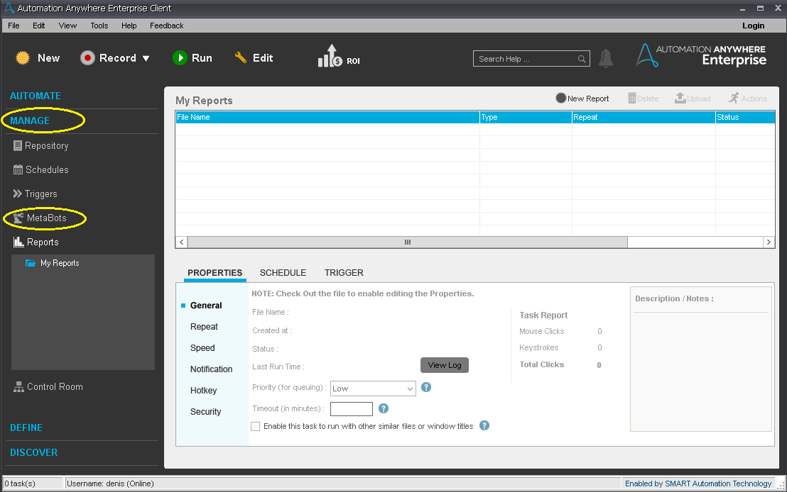
- Select the TPAM item and its children. Then, click the Download button.
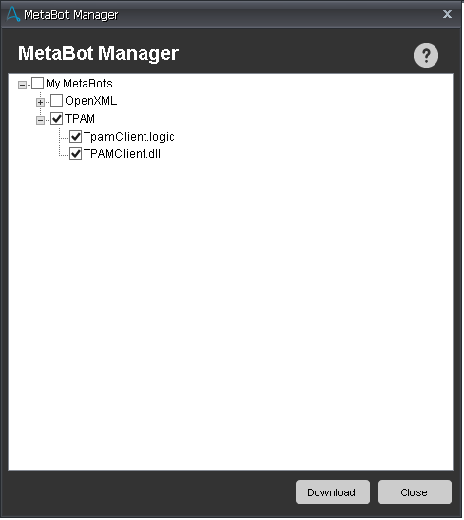

TPAMClient.dll
The .dll contains the logic to invoke the TPAM A2A service. It invokes the WS using the cache user required data and a secured certificate. The certificate should be of type .pfx or .p12.
All required steps are logged into a specific file “TPAMClientLog.txt”. The location of the file is provided by an input parameter.
TPAMClient.dll provides two useful methods.
- SetLogFile(String path, String logLevel)
Where “path” is the location of the log file and “logLevel” is the logger log level.
There 4 types of log level: DEBUG,INFO,WARNING and DIAG. The default is/should be DEBUG.
- getPassword(…)
This method performs the logic to retrieve the password and provide it, if there are no issues.
The parameters of the method are illustrated in the image below:
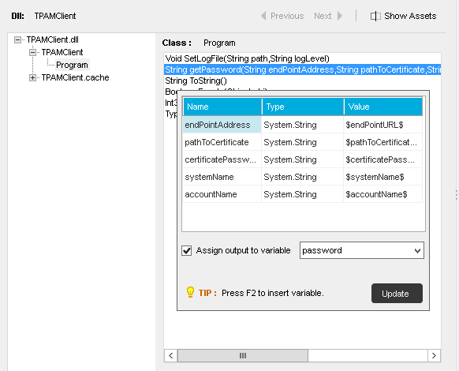

TPAM MetaBot Logic
The TPAM Metabot Logic contains the exception handling on MetaBot level and defines the input and output parameters. Its main duty is to invoke the TPAMClient.dll required methods and provide the password or set the isError parameter as TRUE, in case of any error.
Input / Output parameters
Name | Type | Description
endPointURL | In | The URL of the app2app service.
pathToCertificate | In | Contains the location of the certificate including the file. It accepts .pfx or .p12
certificatePassword | In | Certificate password.
systemName | In | System name.
accountName | In | Account name of the cache user.
password | Out | The result of the app2app service. In case of any error it will be empty.
isError | Out | Default value is FALSE. Provides TRUE in case of errors.

TPAM Task Bot Component
TPAM Task Bot Component (TPAMClientTemplate) is a task, which can be used by the end user as a template. It shows how the MetaBot can be used in the task. Additionally, it contains the ability to read a configuration file, log the required information, use retry logic, if necessary. As an input parameter, it must receive a configuration file and provide the password (from TPAM) and isError variable.
The end user has to edit this task. He must set the certificate password directly into the MetaBot’s input parameters (see image below) as the field type is ‘Password’. By this, it ensures that no one can see the content of the password.
The Task Bot requires a valid XML configuration file and existing directory for logs.
The default location of the task bot is under: “Automation Anywhere\My Tasks\ISG\Common\TPAM\TPAMClientTemplate.atmx”.

Setup TPAM MetaBot
The MetaBot should be available under the “My MetaBots” list, unless it exists.
First click on a desired line in the “Task Actions List” then perform “Double Click” on the “TPAM” item from the “My MetaBots” list.
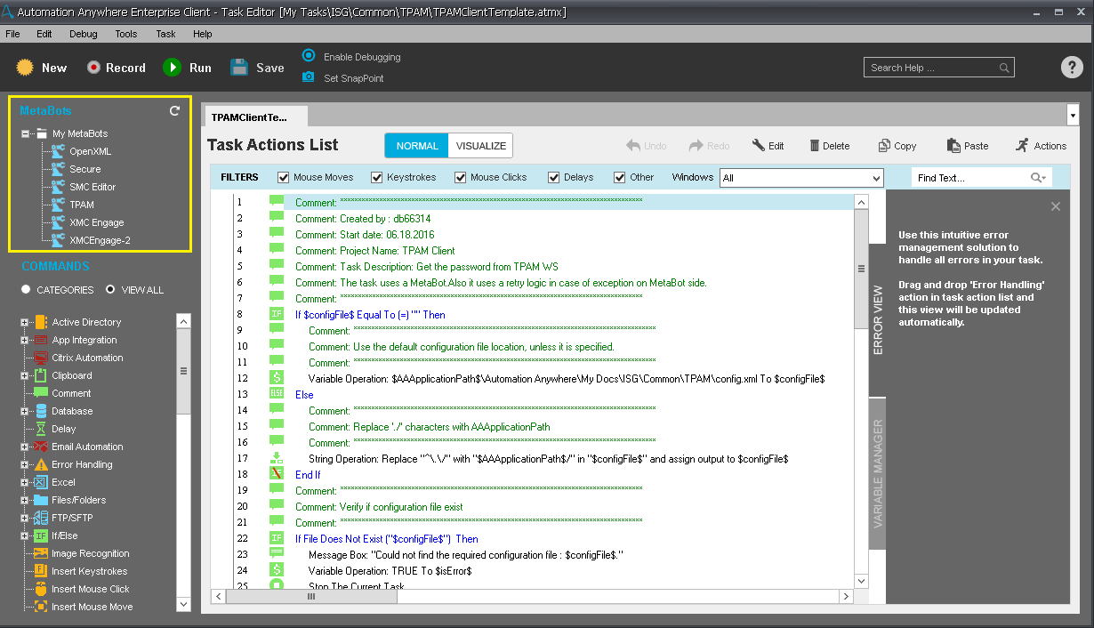
A dialog window should pop up (see image below). In this window it’s required to full all the input and output parameters either by using variables or hard code.
Note: The certificate password must be hard coded directly in the certificatePassword field. It ensures password protection.
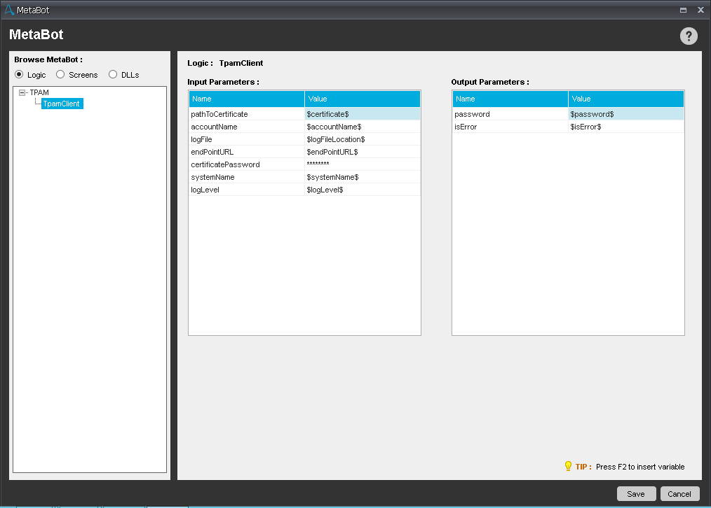

Configuration file
The TPAMClientTemplate task requires a configuration file in order to provide the password. The configuration file has a XML format and contains all the necessary data in order to invoke the TPAM MetaBot properly. Also, it contains data related to logging and retry functionality.
By default, the configuration file (config.xml) is located under: “Automation Anywhere Files\Automation Anywhere\My Docs\ISG\Common\TPAM”.
Default content of the config.xml file:
<configuration>
<TPAMService>
<endPointURL>https://app2app-prod25.nsroot.net/HandlePWRequestService/HandlePWRequest</endPointURL>
<certificate>./Automation Anywhere/My Docs/ISG/Common/TPAM/Certificates/key.pfx</certificate> <systemName>SMCD2</systemName> <accountName>smctptest</accountName>
</TPAMService>
<logger>
<location>./Automation Anywhere/My Docs/ISG/Common/TPAM/Logs</location>
<level>DIAG</level>
</logger>
<retry>
<amount>2</amount>
</retry>
</configuration>

Retry logic
In case there are errors on a MetaBot side, the MetaBot will provide “isError” variable as TRUE. In this case, retry logic will be used. Therefore, the MetBot will be invoked N times, depending on the value from the configuration file. If after N times the “isError” value is the same (TRUE), it will log an error message into the log file.

Logging
There are three types of logging. On the TPAMClient.dll, MetaBot level and TPAMClientTemplate task level. All necessary information is logged in the same log file. The path to the log file is specified in the configuration file “/logger/location”. The specified path must exist in the system. If the path exists, but there is no specific folder, the folder and log file will be created automatically.
It is also possible to specify the log level. There are 4 types of log level. INFO, WARNING, DEBUG and DIAG. DIAG means diagnostic. It will log all information including input parameters except “certificatePassword”.

TPAM Component Installation steps

- Import TPAM metabot
- Put config.xml configuration file in some directory under My Docs folder
- Put TPAMClientTemplate.atmx TaskBot file in some directory under My Tasks folder
- Modify line 12 of TPAMClientTemplate.atmx with the path from #2
- Update configuration file (config.xml) sections with a project specific information:
<TPAMService> node:
<certificate> - Full path to the certificate file
<systemName>- The name of the device, database, or application the privileged accounts need to access.
<accountName>- Account Name for TPAM robotic ID

<logger> node:
<location>- Directory for TPAM component log files

TPAM Contacts and Support

 CATE TPAM & App2App Website:
o TPAM https://catecollaboration.citigroup.net/domains/security/isp_standards/hsestds/hsehomepages/tpam.aspx
o App2App https://catecollaboration.citigroup.net/domains/security/isp_standards/hsestds/hsehomepages/app2app.aspx

 ServiceNow: https://servicemanagement.citigroup.net
 Citi Marketplace: https://cmp.nj.ssmb.com

